**Welcome To Team 2**

Welcome the women to us today. We are pleased to introduce MADAM's Boutique for women's fashion shopping. This is a review of our website.

**1.Home page**

The following snapshots illustrate the creation of MADAM's Boutique.COM home page:

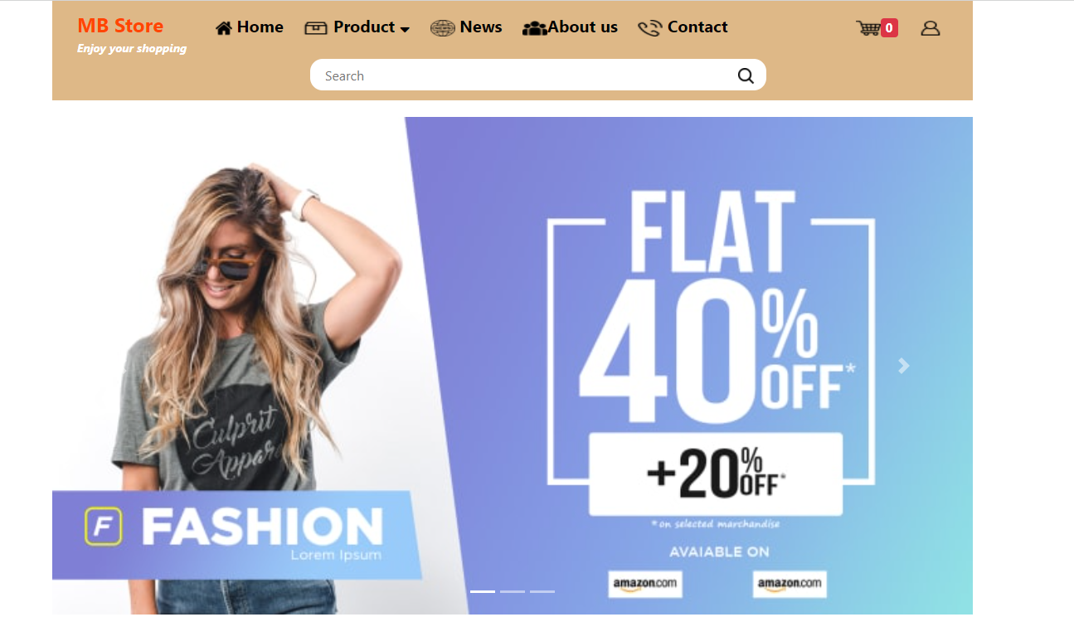

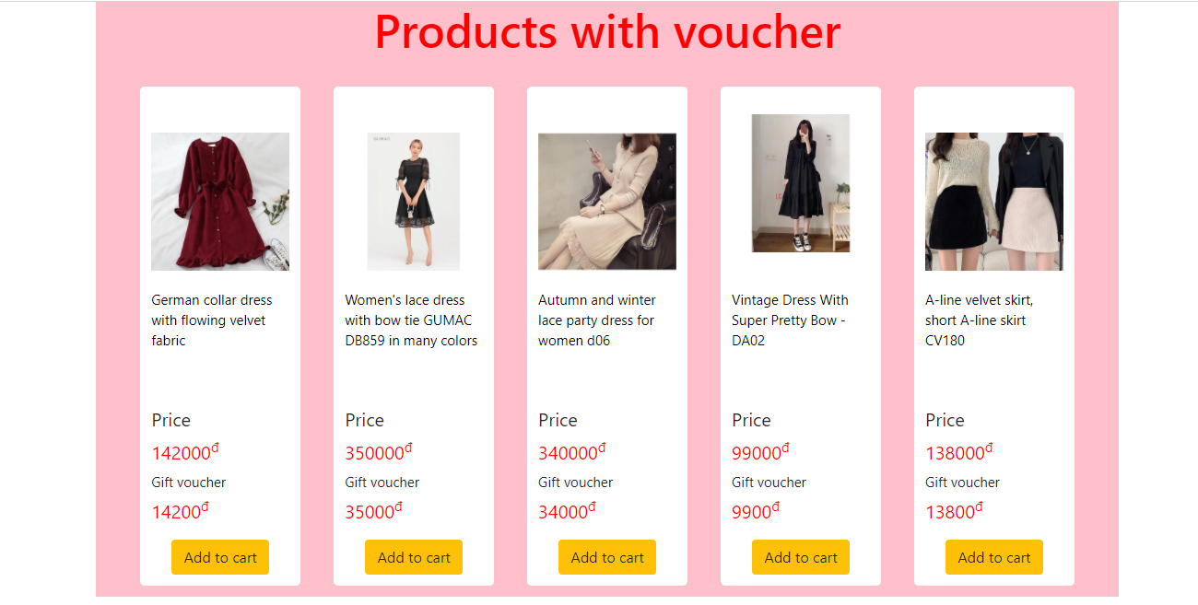

**2. Product details Page**

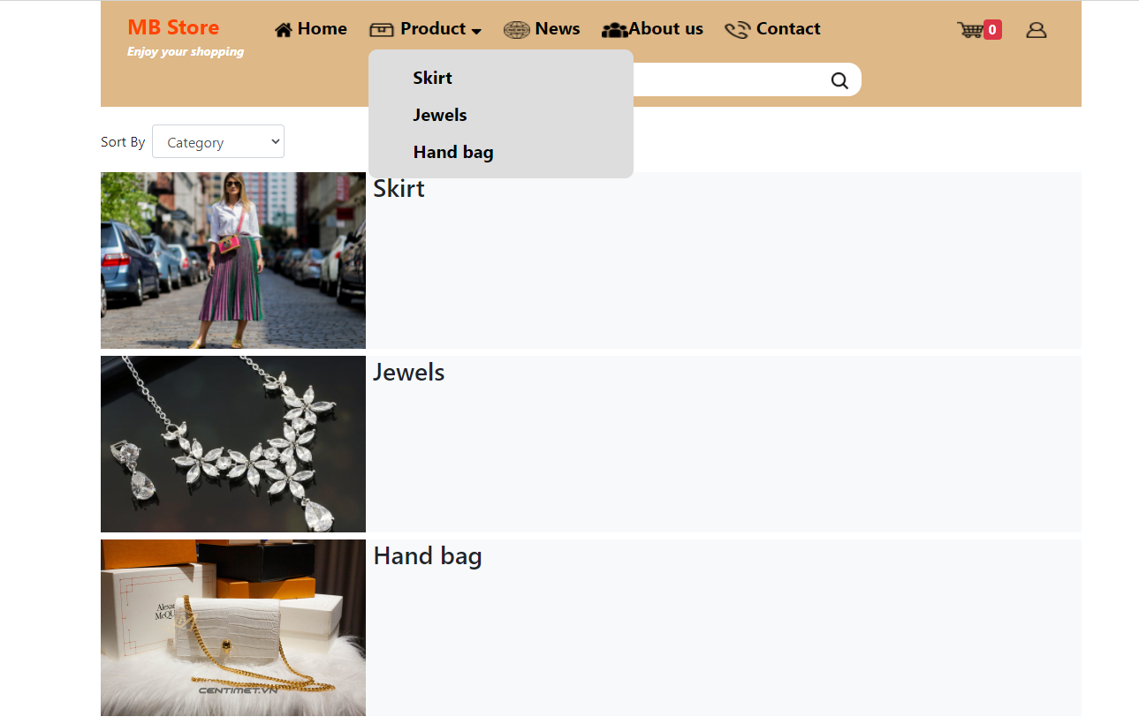

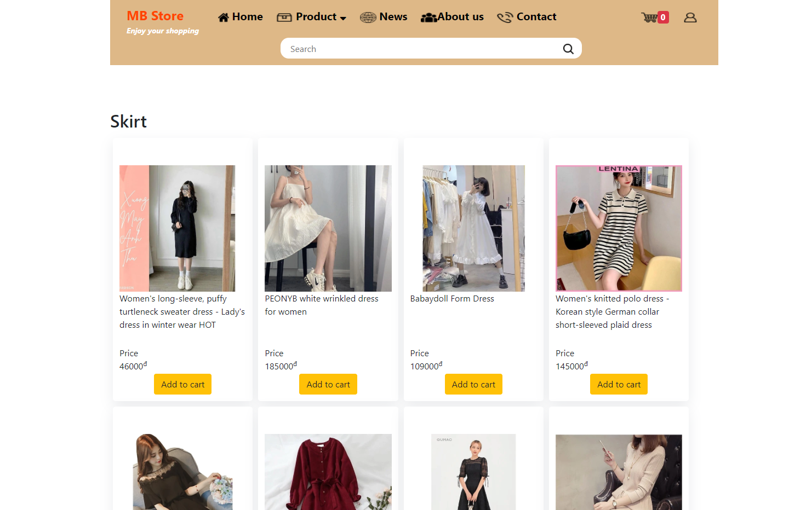

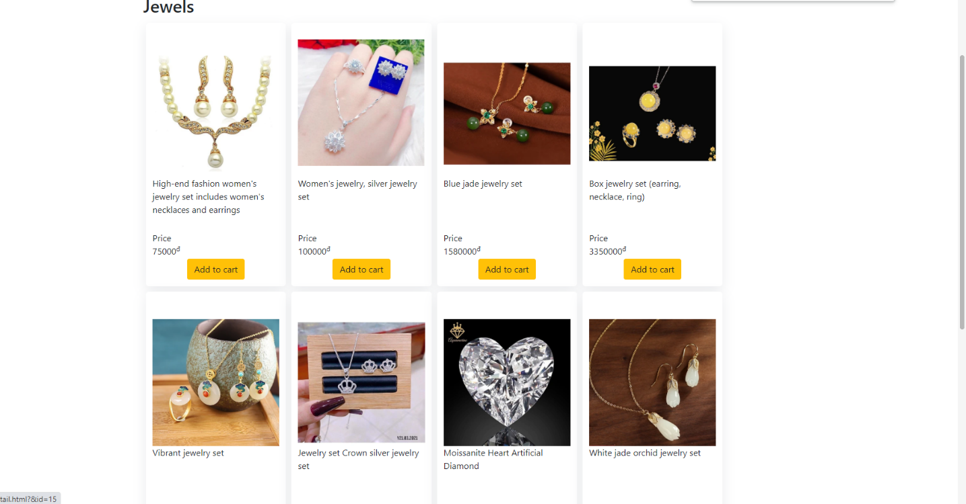

**3.About Us page**

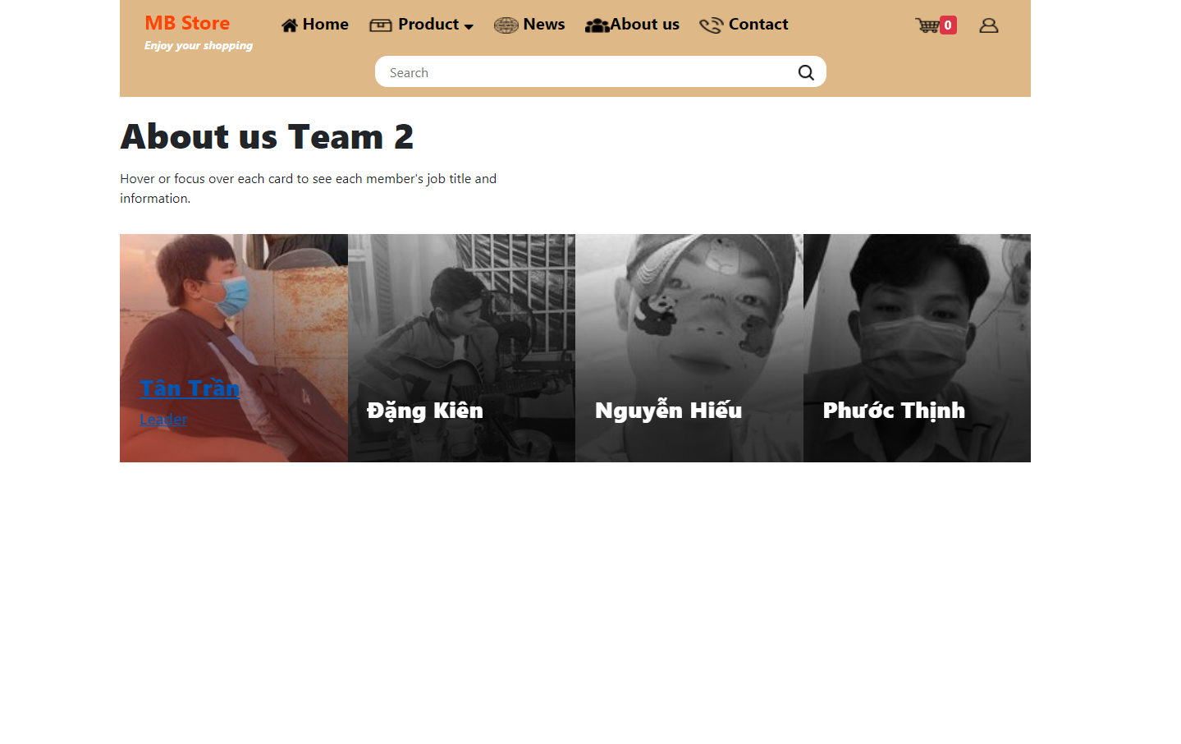

**4.Contact Us page**

The following snapshots illustrate the creation of MADAM's Boutique.COM contact us page:

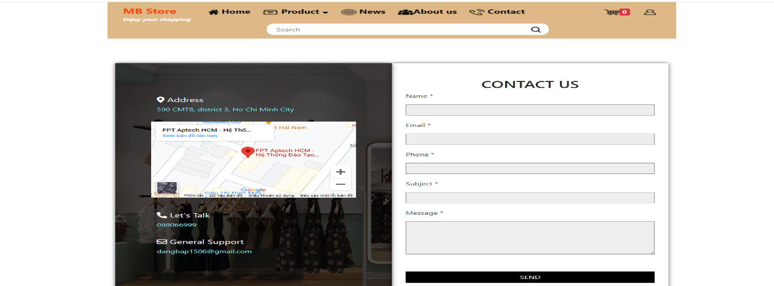

**5.Register and Login page**

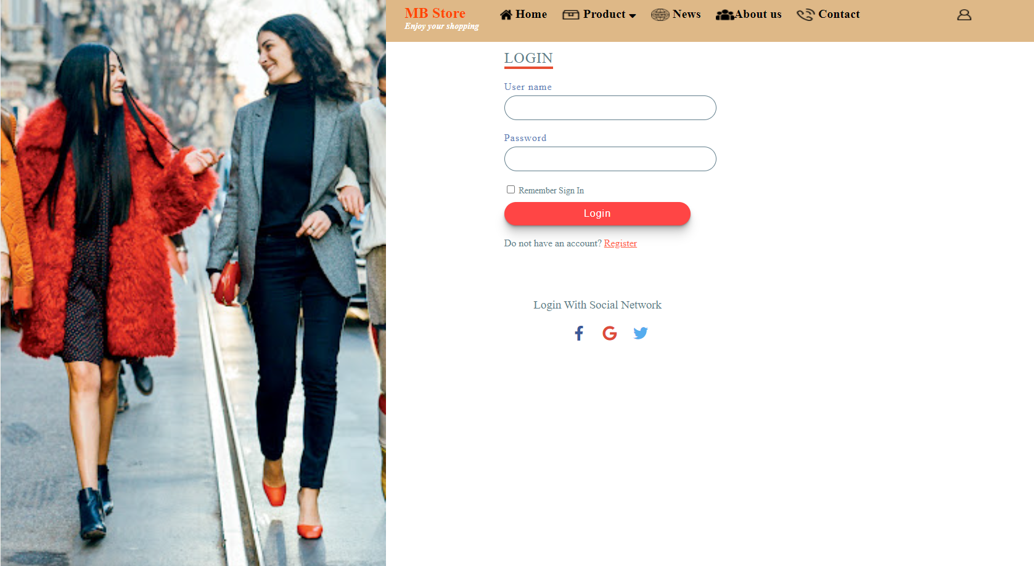

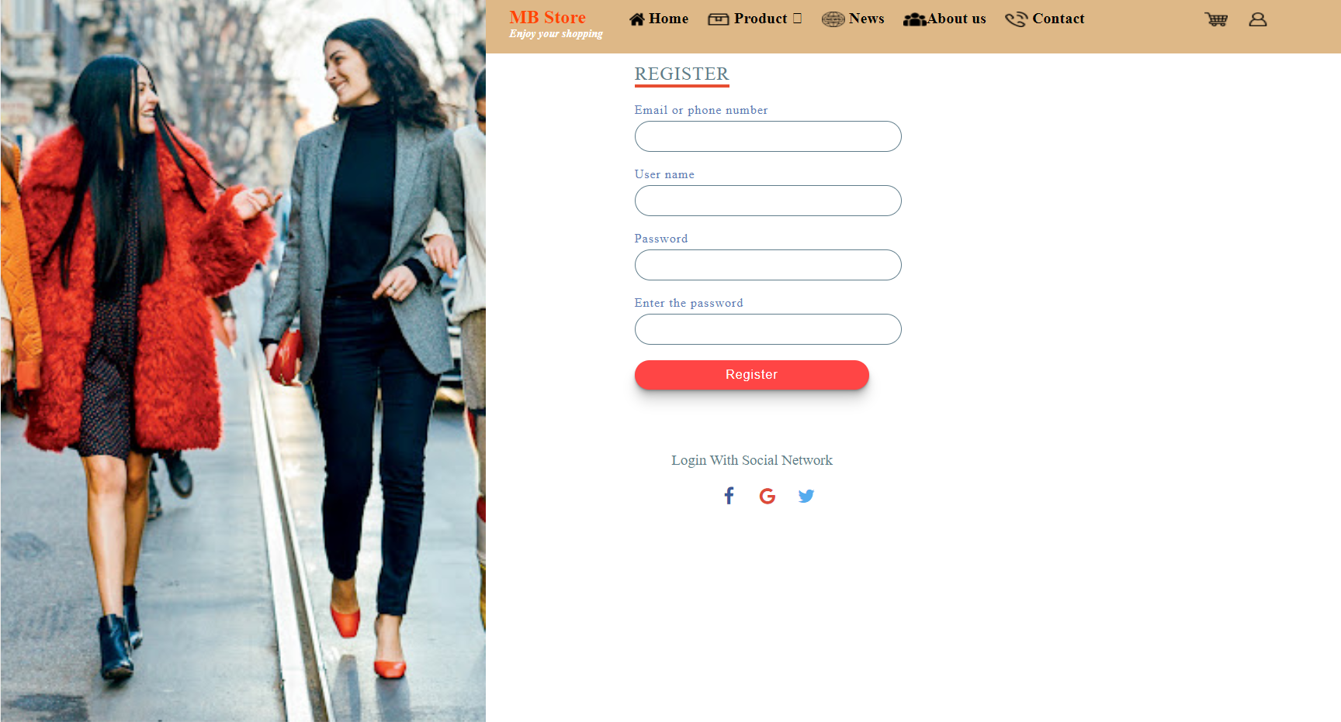

**6.Footer**

The following snapshot illustrates the creation of MADAM's Boutique.COM footer session

